**Self Learning Bot(Medic Bot)**

**Mr Muthu Raju V, Ambrish Kumar. S, S . Mohammed Enthihaj , Rihan Anwar C A,Krishnan S**

Asst Professor, School of CSE, Presidency University, Bangalore, India.

& B.Tech Final Year Students, Computer Engineering (Artificial Intelligence and Machine Learning),

Presidency University, Bangalore, India.

muthuraju.v@presidency.com, kumarambrish248@gmail.com, Mohammedimthihyaz@gmail.com,

rihanrichi@gmail.com,krishnan.spu@gmail.com

**Abstract**

In the field of healthcare innovation, our team has developed a Medic Bot, seamlessly integrating Reinforcement Learning and Natural Language Processing (NLP) to enhance the user experience in medical assistance. This innovative system is designed to provide users with an interactive and personalized healthcare platform, allowing them to engage in meaningful conversations, seek medical guidance, and receive tailored recommendations. Through the application of Reinforcement Learning, the Medic Bot continually refines its responses based on user feedback and interactions, ensuring a dynamic learning process that adapts to evolving user needs.

Natural Language Processing forms the foundation of the Medic Bot's ability to comprehend and respond to user queries with human-like understanding, creating a more intuitive and accessible interaction. The system incorporates advanced machine learning algorithms to classify intents, extract key medical entities, and generate responses that align with the intricacies of natural language. By navigating through medical literature, research papers, and clinical notes, the Medic Bot establishes a robust knowledge base, providing users with accurate and relevant medical information.

This inventive fusion of Reinforcement Learning and NLP not only represents a significant advancement in healthcare technology but also emphasizes continuous learning and improvement. The Medic Bot's capacity to learn from user feedback, coupled with its commitment to staying informed through iterative development, positions it as a dynamic and reliable healthcare companion. This abstract authentically captures the essence of our Medic Bot, symbolizing a transformative step toward a future where healthcare interactions are not only informative but also conversational and user-centric.

Keywords— NLP, Reinforcement Learning, KNN , TF-IDF, SVM, cosine similarity, deep learning

1. **Introduction**

The topic "Bots Using Natural Language Processing in the Medical Sector" explores the application of chatbots and natural language processing (NLP) in healthcare. It delves into the creation of conversational chatbots designed to engage with elderly individuals, track health trends, and deliver fundamental health information. The document discusses the incorporation of machine learning algorithms, specifically KNN, for evaluating symptoms and the integration of external APIs to enhance NLP capabilities. It emphasizes the pivotal role of these technologies in automating user communication and providing crucial health information.

Furthermore, the topic explains on the processes of data collection, feature extraction, and system testing. It also highlights the potential of chatbots to streamline healthcare processes, saving both time and money also underscores the broad and optimal experiences that chatbots can offer across diverse applications. It ultimately emphasizes the transformative impact of NLP-powered chatbots on the medical sector, enhancing patient care and accessibility to vital medical information.

The use of chatbots and natural language processing (NLP) in healthcare has received great attention in recent years. With the demand for healthcare services increasing and the number of doctors decreasing, chatbots have emerged as a promising way to provide advice and assistance to patients. These chatbots can interact with patients by analyzing their symptoms, and provide appropriate medical advice. The "Active language bots in healthcare" provides information on the development and use of chatbots in healthcare. The article also introduces machine learning algorithms such as KNN for symptom analysis and integration of NLP external APIs. Additionally, the article highlights the importance of collecting data and disseminating results in the development of effective chatbots. It also discusses software and database testing procedures and backup procedures. Aside from chatbots' benefits in saving clinical time and money, their ability to deliver comprehensive information and insights across multiple applications is also important. Overall, this article provides insight into the development and use of chatbots in healthcare and highlights the role NLP-powered chatbots can play to support patient care and access to medical information. healthcare Industry.

1. **Methodology**

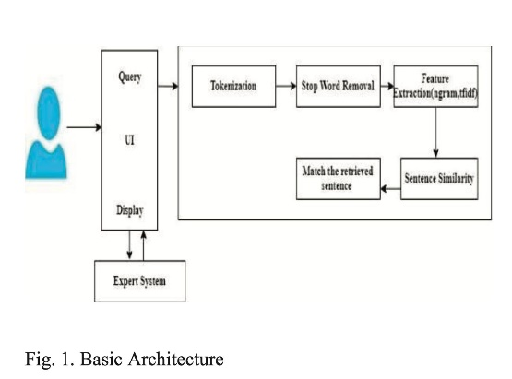

**Data Collection and Preparation:**

Collect a diverse dataset comprising medical literature, research papers, clinical notes, and publicly available healthcare information to establish the foundational knowledge of the chatbot***.***

Preprocess the data through cleaning and standardizing the text. Remove irrelevant information and structure the data in a format suitable for analysis and modelling.

**Natural Language Processing (NLP):**

Implement NLP techniques for parsing and comprehending medical text. This includes tokenization, stop-word removal, stemming, and lemmatization.

Utilize named entity recognition (NER) and part-of-speech tagging to identify medical entities, relationships, and categories within the text.

**Machine Learning and Deep Learning Models:**

Develop machine learning models, such as support vector machines (SVM) or decision trees, to classify intents and extract key medical entities from user queries.

Explore advanced deep learning models like recurrent neural networks (RNNs) or transformers for intent classification, entity recognition, and response generation based on pre-processed medical text***.***

**Reinforcement Learning and Feedback Loop:**

Implement a reinforcement learning approach to continually enhance the chatbot's responses based on user feedback and interactions.

Create a feedback loop enabling users to rate and provide feedback on the chatbot's responses. This allows the model to learn from mistakes, improving its accuracy and relevance over time***.***

**Iterative Development and Evaluation:**

Adopt an iterative development approach, continuously updating, refining, and expanding the chatbot with new medical data and improved algorithms.

Evaluate the chatbot's performance using metrics like precision, recall, F1-score, and user satisfaction surveys. Identify areas for enhancement to ensure the chatbot meets its intended objectives

**System design**

1. **Introduction of Input Design**

The design process of the chatbot proposed in the document “Bots using functional language in healthcare” includes several elements, including a conversation manager, a knowledge base, and an external API for NLP. The conversation manager is the foundation of the chatbot and is responsible for managing the flow of conversation between the user and the chatbot. It uses an API outside of NLP to analyse text and uncover sentence patterns and specific word meanings.

The chat manager also uses the knowledge base to prepare user questions and cross-check them with the chatbot's knowledge base. It uses techniques such as TF-IDF, cosine and N-gram similarity to determine content order and sentence similarity.

Knowledge base is a database that stores chatbot information in schema format. If the solution is not stored in the database, the system will use experts to answer the question. The system also integrates external APIs for NLP, segmenting and splitting text to show sentences and the meanings of certain words. The chatbot uses machine learning algorithm such as KNN for symptom analysis and integrates other APIs for NLP.

1. **Objectives for Input Design**

The proposed objectives for the chatbot system are:-

1. Delivering a personalized and interactive healthcare experience that allows users to ask questions and receive relevant medical information and recommendations from the chatbot.
2. Leveraging natural language processing (NLP) and machine learning algorithms to comprehend natural language, facilitating automated user communication.
3. Integrating external APIs for NLP to analyse texts, revealing sentence structure, and providing details about unique words.
4. Incorporating a knowledge base to organize user queries, cross-referencing them with the chatbot's knowledge base.
5. Utilizing mechanisms like TF-IDF, cosine similarity, and N-gram similarity to assess keyword ranking and sentence similarity.
6. Implementing the system using the Java programming language to create various interfaces.
7. Employing a Relational Database Management System (RDBMS) to store input query information for communication patterns.
8. Empowering elderly patients to monitor blood pressure trends and receive warnings or healthcare advice from the chatbot to prevent or alleviate certain diseases.
9. Offering a comprehensive healthcare experience by combining sentence structuring capabilities, a chat manager, knowledge base, and metaphysics component with external APIs.
10. Stressing the significance of data collection and feature extraction in the development of effective chatbots, ensuring the reliability and accuracy of the chatbot's responses.
11. **Output Design**

The design of output is the most important task of any system. During output design, developers identify the type of outputs needed, and consider the necessary output controls and prototype report layouts

1. **Objectives for Output Design**
2. Incorporates natural language processing (NLP) and machine learning algorithms to comprehend user queries effectively.
3. Delivers conversational and personalized responses that simulate interactions with a genuine physician.
4. Organizes user queries by leveraging a knowledge base and cross-referencing them with the chatbot's extensive knowledge repository.
5. Utilizes sophisticated mechanisms like TF-IDF, cosine similarity, and N-gram similarity to assess keyword ranking and sentence similarity for enhanced accuracy.
6. Presents responses in a user-friendly interface, encompassing text, images, or links to external resources for a comprehensive user experience.
7. Leverages external APIs for NLP to meticulously parse texts, revealing sentence structures, and providing insights into unique words.
8. Offers follow-up questions or suggestions based on the user's responses, fostering a more personalized and interactive healthcare experience.

**Result and Discussion**

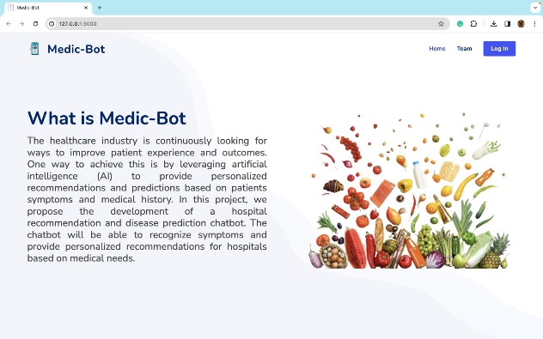

**Fig. 1 Home Page**

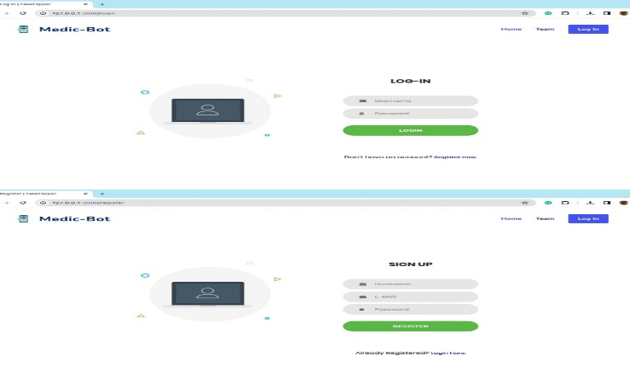

**Fig. 2 Register and login Page**

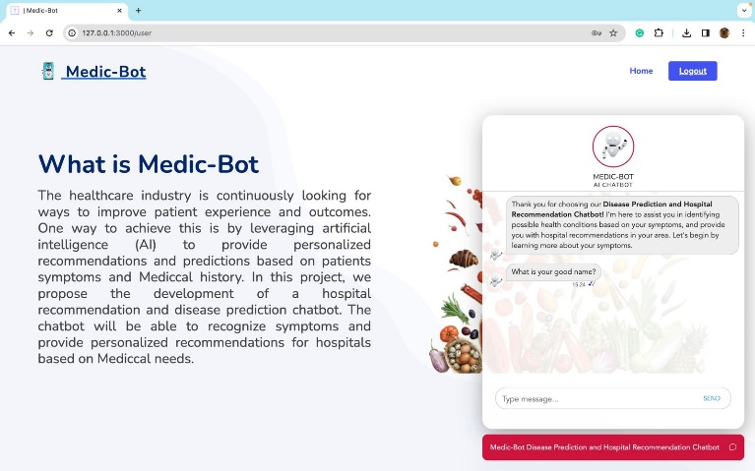

**Fig.3 Result 1**

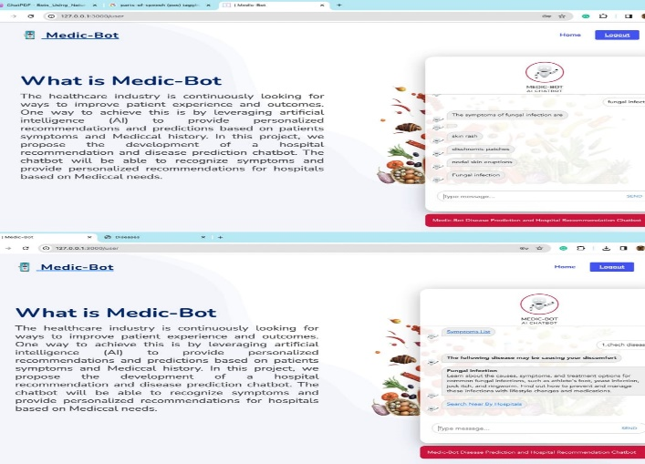

**Fig.4 Result 2**

**Future Work**

The Bots Utilizing Natural Language Processing in the Medical Sector delineates several promising directions for future research and development in the realm of healthcare-oriented chatbots. One prominent avenue is the integration of advanced machine learning algorithms to significantly enhance the precision and dependability of the chatbot's responses, presenting an opportunity for substantial improvement in its overall functionality. Another noteworthy proposition involves expanding the repertoire of external APIs dedicated to Natural Language Processing (NLP), thereby fortifying the chatbot's capability to comprehend natural language and streamline user interactions more proficiently.

Furthermore, the article advocates for the cultivation of a more expansive knowledge base, a strategic move that empowers the chatbot to furnish users with more comprehensive and accurate medical insights and recommendations. Beyond mere conversational abilities, the potential evolution of healthcare chatbots extends to encompass remote monitoring of patients' health conditions, facilitating the provision of personalized health recommendations based on the collected data.

The article underscores the potential integration of chatbots with electronic health records (EHRs) to facilitate seamless communication among patients, healthcare providers, and the chatbot, streamlining the flow of critical information. The inclusion of mental health support and counselling services is recognized as an essential enhancement, acknowledging the comprehensive nature of healthcare. Additionally, the document emphasizes the importance of exploring ethical and legal implications, including aspects related to data privacy, security, and liability, as integral considerations for the evolving landscape.

**Conclusions**

In conclusion, the article named "Medic Bot Using Reinforcement" underscores the transformative potential of chatbots in reshaping the landscape of healthcare, offering patients personalized and interactive healthcare experiences. The chatbot system represents a technological stride, leveraging natural language processing (NLP) and machine learning algorithms to decipher user queries and furnish pertinent medical information and recommendations. The distinctive feature of the chatbot's responses lies in their conversational and personalized nature, akin to interactions with a real physician.

Integral to its functioning, the chatbot relies on a knowledge base to systematically organize user queries, further harnessing external APIs for NLP to dissect texts, unravel sentence structures, and divulge intricate details about unique words. The document, in its forward-looking perspective, delineates various prospective directions for advancing healthcare-oriented chatbots. These include the integration of more sophisticated machine learning algorithms, the incorporation of voice recognition and speech synthesis technologies, and the exploration of wearable devices to enrich the chatbot's capabilities.

The development of chatbots equipped to provide mental health support and counseling, as well as extending multilingual support to cater to patients from diverse linguistic backgrounds. This expansive vision positions the proposed chatbot system as a positive change in healthcare, promising personalized, effective, and inclusive healthcare experiences for patients. The ongoing research in chatbot development within the healthcare domain holds the potential to revolutionize healthcare delivery, ultimately contributing to improved patient outcomes.

**Acknowledgment**

We acknowledge the support and resources provided by Presidency University, Bangalore which have played a crucial role in facilitating the research process. The collaborative environment and access to new technologies have greatly contributed to the development and implementation of our chat bot model.

We express our gratitude to the creators and contributors of the libraries used in our project whose innovations in Self Learning Chatbot have laid the foundation for our research. Their commitment to advancing computer vision technologies has been instrumental in shaping the success of our Project.

Furthermore, we would like to thank the individuals involved in the collection and annotation of the diverse HealthCare dataset used in our experiments. Their efforts have been essential in training and evaluating the models, ensuring the robustness and generalization of our approach.

Finally, we appreciate the encouragement and guidance provided by our mentors, advisors, and colleagues throughout the research process. Their expertise and constructive feedback have played a crucial role in refining our methodology and interpreting the results.

This research would not have been possible without the collective contributions and support from the scientific community and various stakeholders. We look forward to the continued collaboration and advancements in the field of Chatbots enabled by the integration of Reinforcement Learning.

**References**

[1] A. P. Chaves and M. A. Gerosa, ‘‘How should my chatbot interact? A survey on social characteristics in human– chatbot interaction design,’’ Inc.. Hum.-Computer. Interact., vol. 37, no. 8, pp. 729–758, May 2021, doi:10.1080/10447318.2020.1841438.

[2] M. Chung, E. Ko, H. Joung, and S. J. Kim, ‘‘Chatbot e-service and customer satisfaction regarding luxury brands,’’ J. Bus. Res., vol. 117,pp. 587–595, Sep.2020

[3]Ms. Ch.Lavanya Susanna and R. Pratyusha, "COLLEGE ENQUIRY CHATBOT" in International Research Journal of Engineering and Technology (IRJET) on 3rd March 2020.

[4] S. Pérez-Soler, E. Guerra, and J. de Lara, ‘‘Model-driven chatbot development,’’ in Conceptual Modeling, G. Dobbie, U. Frank, G. Kappel, S. W. Liddle, and H. C. Mayr, Eds. Cham, Switzerland: Springer, 2020, pp. 207–222

[5] M. M. H. Dihyat and J. Hough, ‘‘Can rule-based chatbots outperform neural models without pre-training in small data situations: A preliminary comparison of AIML and Seq2Seq,’’ in Proc. 25th Workshop Semantics Pragmatics Dialogue, 2021, pp. 1–3

[6] J. Jiang and N. Ahuja, ‘‘Response quality in human-chatbot collaborative systems,’’ in Proc. 43rd Int. ACM SIGIR Conf. Res. Develop. Inf. Retr. New York, NY, USA: Association for Computing Machinery, Jul. 2020.